Arithmetic Circuits
A combinational logic circuit is one where the output or outputs depend upon the present state of combination of the logic inputs. The logic gates discussed in earlier constitute the most fundamental building block of a combinational circuit. More complex combinational circuits such as adders and subtractors, multiplexers and demultiplexers, magnitude comparators, etc., can be implemented using a combination of logic gates. However, the aforesaid combinational logic functions and many more, including more complex ones, are available in monolithic IC form. A still more complex combinational circuit may be implemented using a combination of these functions available in IC form.
Combinational Circuits
A combinational circuit is one where the output at any time depends only on the present combination of inputs at that point of time with total disregard to the past state of the inputs. The logic gate is the most basic building block of combinational logic. The logical function performed by a combinational circuit is fully defined by a set of Boolean expressions. The other category of logic circuits, called sequential logic circuits, comprises both logic gates and memory elements such as flip-flops. Owing to the presence of memory elements, the output in a sequential circuit depends upon not only the present but also the past state of inputs.
The figure below shows the block schematic representation of a generalized combinational circuit having n input variables and m output variables or simply outputs. Since the number of input variables is n, there are 2^{n}possible combinations of bits at the input. Each output can be expressed in terms of input variables by a Boolean expression.
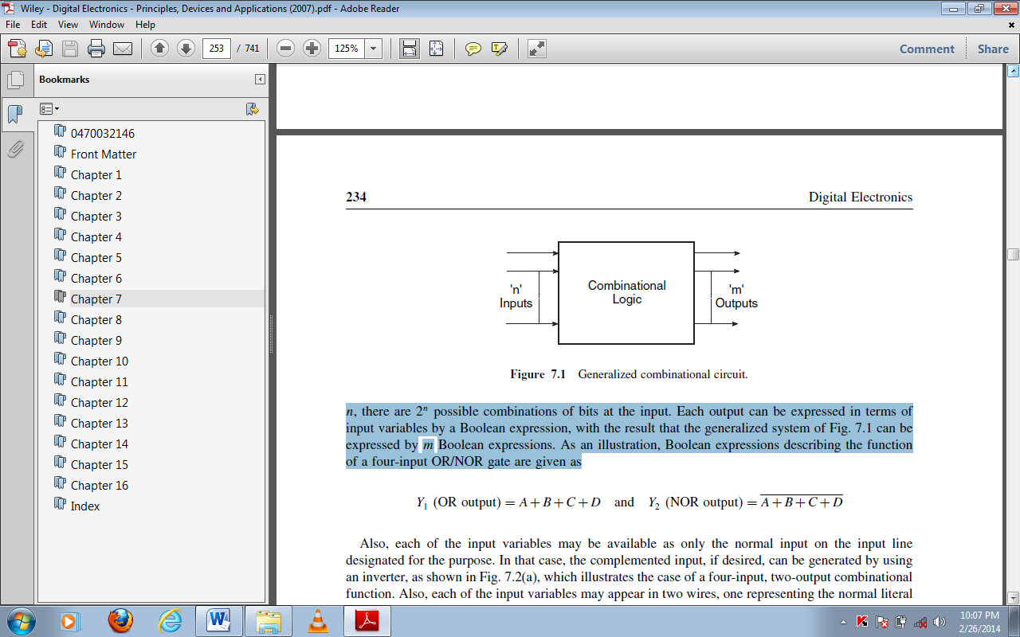
Implementing Combinational Logic
The different steps involved in the design of a combinational logic circuit are as follows:
1. Statement of the problem.
2. Identification of input and output variables.
3. Expressing the relationship between the input and output variables.
4. Construction of a truth table to meet input–output requirements.
5. Writing Boolean expressions for various output variables in terms of input variables.
6. Minimization of Boolean expressions.
7. Implementation of minimized Boolean expressions.
There are various simplification techniques available for minimizing Boolean expressions, which have been discussed in the previous lessons. Also, there are various possible minimized forms of Boolean expressions. The following guidelines should be followed while choosing the preferred form for hardware implementation:
1. The implementation should have the minimum number of gates, with the gates used having the minimum number of inputs.
2. There should be a minimum number of interconnections, and the propagation time should be the shortest.
3. Limitation on the driving capability of the gates should not be ignored.
Half-Adder
A half-adder is an arithmetic circuit block that can be used to add two bits. Such a circuit thus has two inputs that represent the two bits to be added and two outputs, with one producing the SUM output and the other producing the CARRY. The figure below shows the truth table of a half-adder, showing all possible input combinations and the corresponding outputs. The Boolean expressions for the SUM and CARRY outputs are given by the equations
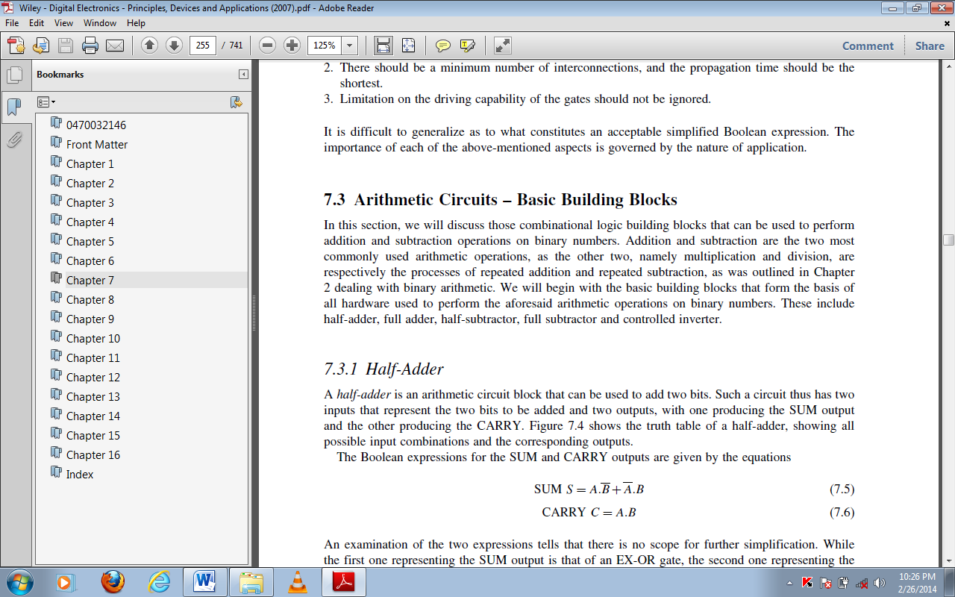
The first expression one representing the SUM output is that of an EX-OR gate, and the second one representing the CARRY output is that of an AND gate.
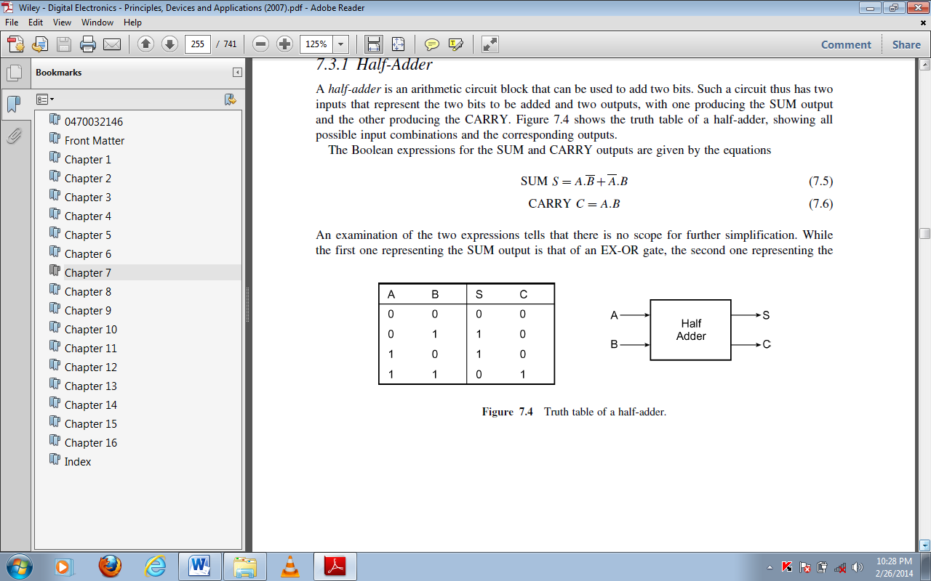

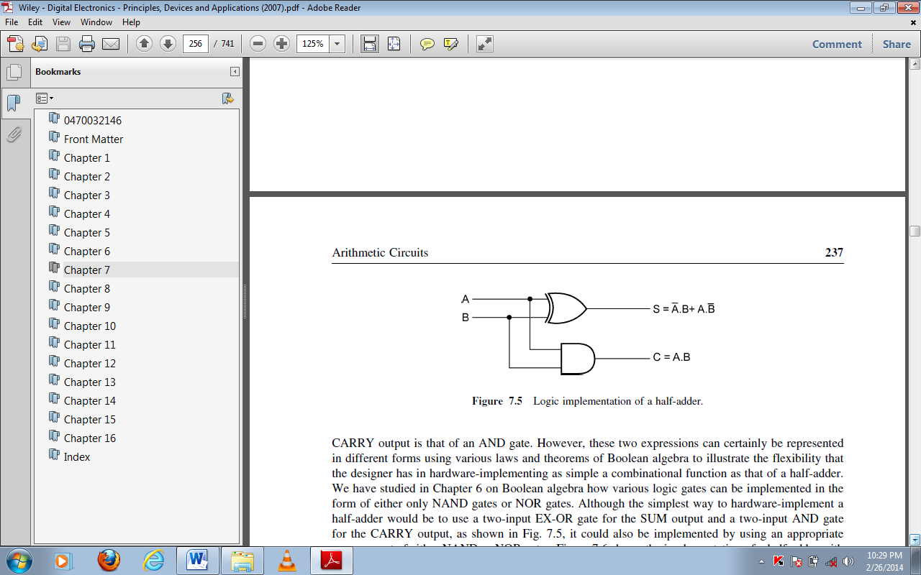
However, these two expressions can certainly be represented in different forms using various laws and theorems of Boolean algebra to illustrate the flexibility that the designer has in hardware-implementing as simple a combinational function as that of a half-adder. For example the figure below shows the implementation of a half-adder with
NAND gates only.
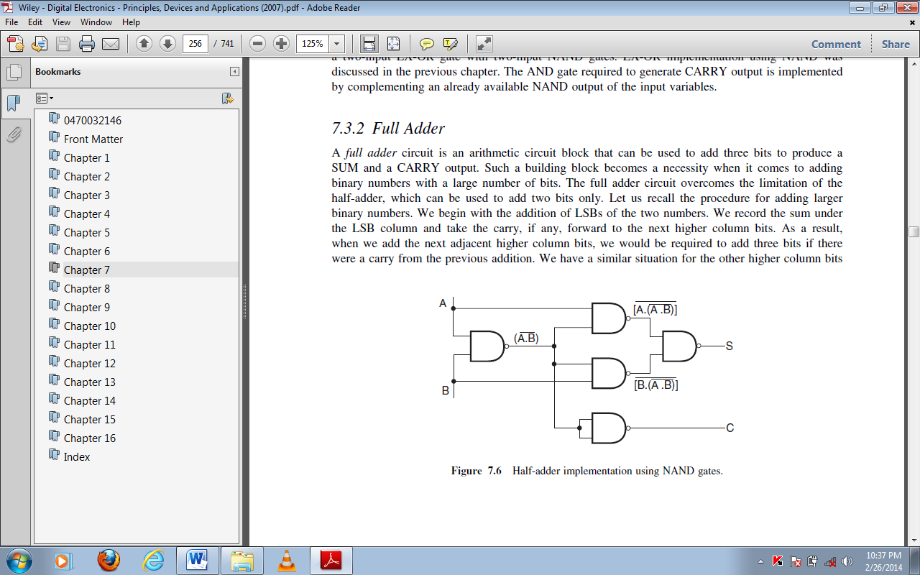

Full Adder
A full adder circuit is an arithmetic circuit block that can be used to add three bits to produce a SUM and a CARRY output. Such a building block becomes a necessity when it comes to adding binary numbers with a large number of bits. The full adder circuit overcomes the limitation of the half-adder, which can be used to add two bits only. We begin with the addition of LSBs of the two numbers. We record the sum under the LSB column and take the carry, if any, forward to the next higher column bits. As a result, when we add the next adjacent higher column bits, we would be required to add three bits if there were a carry from the previous addition. We have a similar situation for the other higher column bits also until we reach the MSB. A full adder is therefore essential for the hardware implementation of
an adder circuit capable of adding larger binary numbers. A half-adder can be used for addition of LSBs only.
The figure below shows the truth table of a full adder circuit showing all possible input combinations and corresponding outputs. In order to arrive at the logic circuit for hardware implementation of a full adder, we will firstly write the Boolean expressions for the two output variables, that is, the SUM and CARRY outputs, in terms of input variables. These expressions are then simplified by using any of the simplification techniques described in the previous chapter. The Boolean expressions for the two output variables are given.
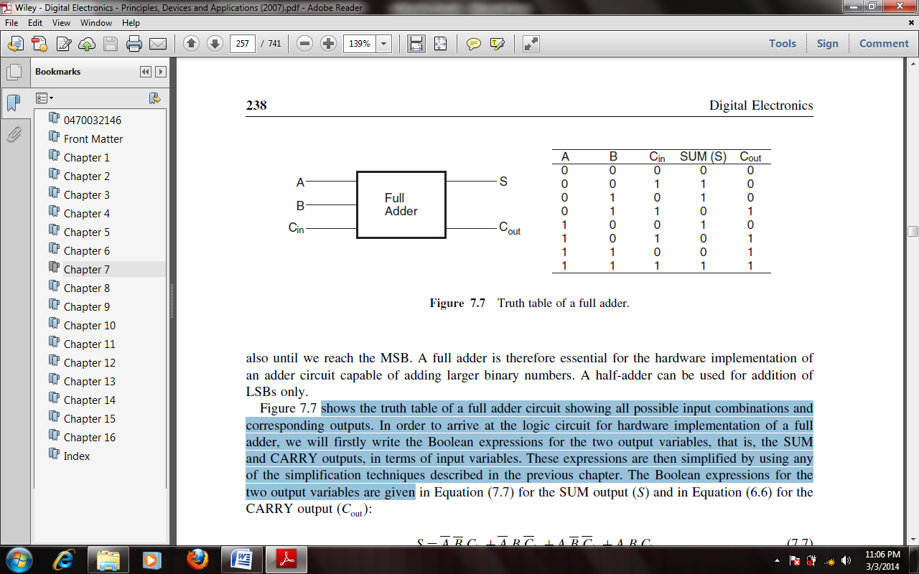
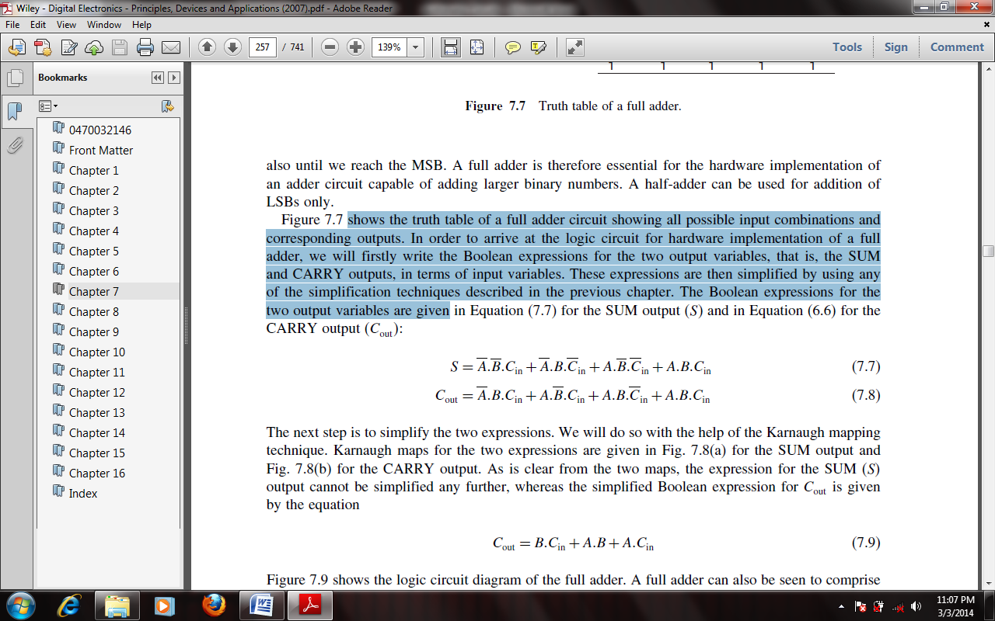
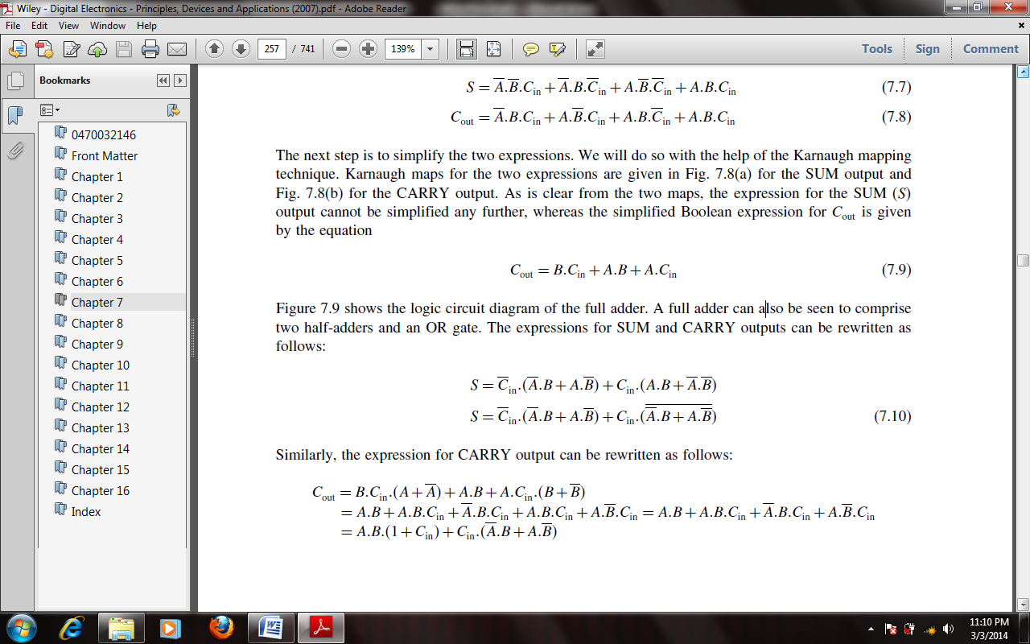

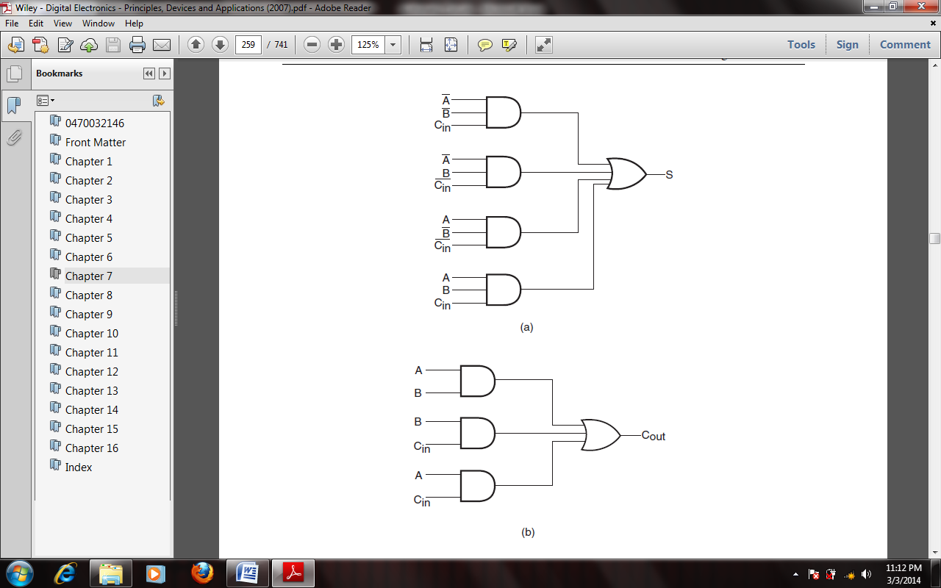

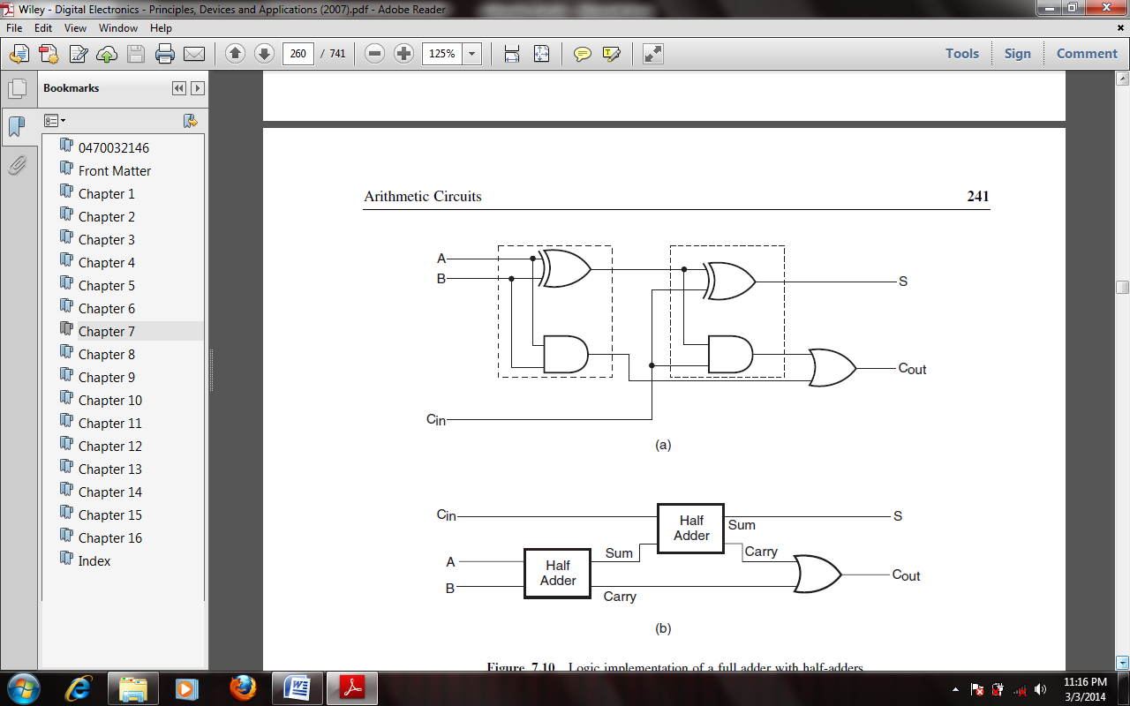

The full adder of the type described above forms the basic building block of binary adders. However, a single full adder circuit can be used to add one-bit binary numbers only. A cascade arrangement of these adders can be used to construct adders capable of adding binary numbers with a larger number of bits. For example, a four-bit binary adder would require four full adders of the type connected in cascade. The figure below shows such an arrangement. (A3A2A1A0) and (B3B2B1B0) are the two binary numbers to be added, with A0 and B0 representing LSBs and A3 and B3 representing MSBs of the two numbers.
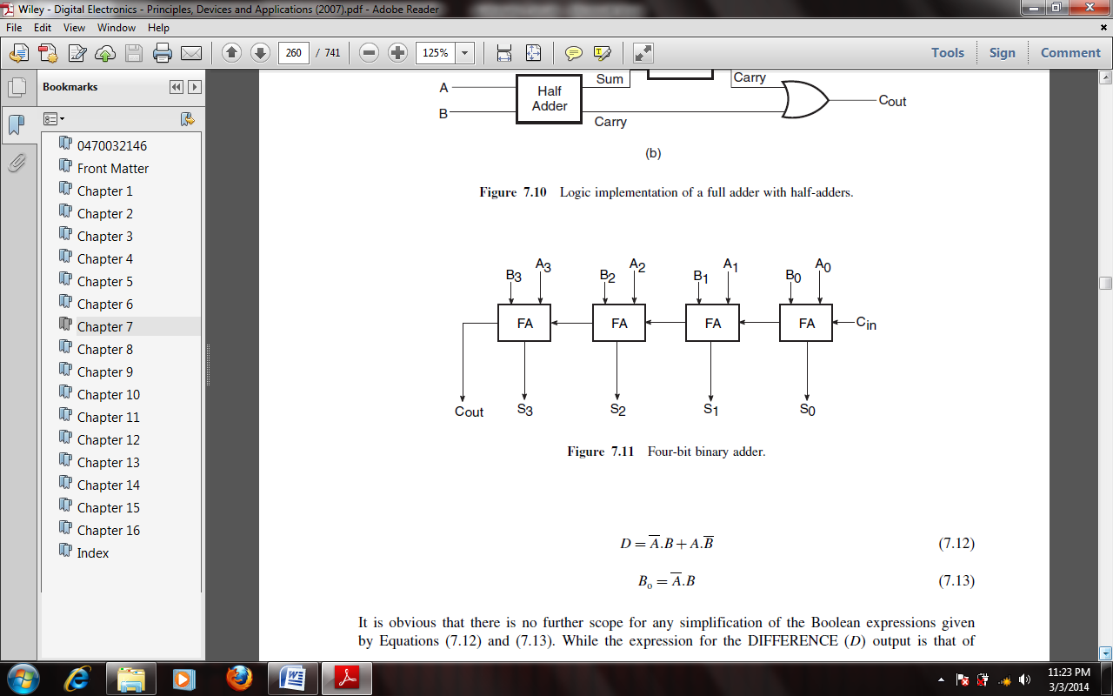
Adder–Subtractor
Subtraction of two binary numbers can be accomplished by adding 2’s complement of the subtrahend to the minuend and disregarding the final carry, if any. If the MSB bit in the result of addition is a ‘0’, then the result of addition is the correct answer. If the MSB bit is a ‘1’, this implies that the answer has a negative sign. The true magnitude in this case is given by 2’s complement of the result of addition.
Full adders can be used to perform subtraction provided we have the necessary additional hardware to generate 2’s complement of the subtrahend and disregard the final carry or overflow. The figure below shows one such hardware arrangement. Let us see how it can be used to perform subtraction of two four-bit binary numbers. A close look at the diagram would reveal that it is the hardware arrangement for a four-bit binary adder, with the exception that the bits of one of the binary numbers are fed through controlled inverters. The control input here is referred to as the SUB input. When the SUB input is in logic ‘0’ state, the four bits of the binary number (B3 B2 B1 B0) are passed on as such to the B inputs of the corresponding full adders. The outputs of the full adders in this case give the result of addition of the two numbers. When the SUB input is in logic ‘1’ state, four bits of one of the numbers, (B3 B2 B1 B0) in the present case, get complemented. If the same ‘1’ is also fed to the CARRY-IN of the LSB full adder, what we finally achieve is the addition of 2’s complement and not 1’s complement. Thus, in the adder arrangement of this figure, we are basically adding 2’s complement of (B3 B2 B1 B0) to (A3 A2 A1 A0). The outputs of the full adders in this case give the result of subtraction of the two numbers. The arrangement shown achieves A−B. For implementing an eight-bit adder–subtractor, we will require eight full adders and eight two-input EX-OR gates.

